|  |  |
| --- | --- |
| **PIPING MODULE** | **Deployment** |

1. **Software Installation**

Install the required Softwares

|  |  |  |
| --- | --- | --- |
| **#** | **Software** | **Installer** |
| 1 | Web Server – IIS 10 |  |
| 2 | AspNet Core Module V2 | <https://dotnet.microsoft.com/download/dotnet-core/thank-you/runtime-aspnetcore-3.1.1-windows-hosting-bundle-installer> |
| 3 | Web Browser - Chrome |  |
| 4 | Postgresql 12 | <http://www.enterprisedb.com/postgresql-tutorial-resources-training?cid=48> |

**Install Asp.net Core Module**

1. Click the below link to downloadthe installer **dotnet-hosting-3.1.0-win**

[**https://dotnet.microsoft.com/download/dotnet-core/thank-you/runtime-aspnetcore-3.1.1-windows-hosting-bundle-installer**](https://dotnet.microsoft.com/download/dotnet-core/thank-you/runtime-aspnetcore-3.1.1-windows-hosting-bundle-installer)



1. Install the **dotnet-hosting-3.1.0-win**

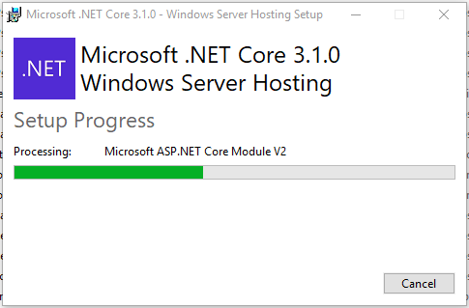

1. Now can see this Under IIS » Modules » AspNetCoreModuleV2

|  |  |  |
| --- | --- | --- |
|  |  |  |

1. **Extract Compiled Code from GIT**

Extract the compiled code from the below location and configure the

Database Connection in API

<https://gitlab.com/senecagobal/incubation/pipingpoc>

|  |  |  |
| --- | --- | --- |
| **#** | **Application** | **Path** |
| 1 | Piping API | <https://gitlab.com/senecagobal/incubation/pipingpoc/Piping_API> |
| 2 | Piping UI | <https://gitlab.com/senecagobal/incubation/pipingpoc/Piping_UI> |
| 3 | Piping DB | <https://gitlab.com/senecagobal/incubation/pipingpoc/Piping_DB> |

**Configure the Database connection**

Open appsettings.Production.json file in Piping_API folder and configure

the Piping connection and Serilog.

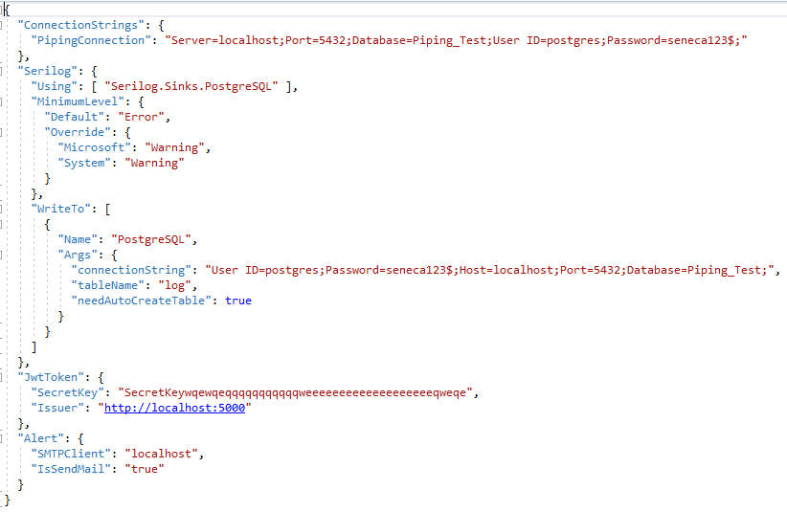

1. **Deployment**

Deploy API and UI in IIS and execute the scripts to create DB

|  |  |  |
| --- | --- | --- |
| **#** | **Folder** | **Deployment** |
| 1 | Piping API | IIS |
| 2 | Piping UI | IIS |
| 3 | Piping DB | Postgresql |

**PIPING API Deployment in IIS**

1. Deploy extracted Piping_API folder in IIS. Add Website Piping_API in IIS

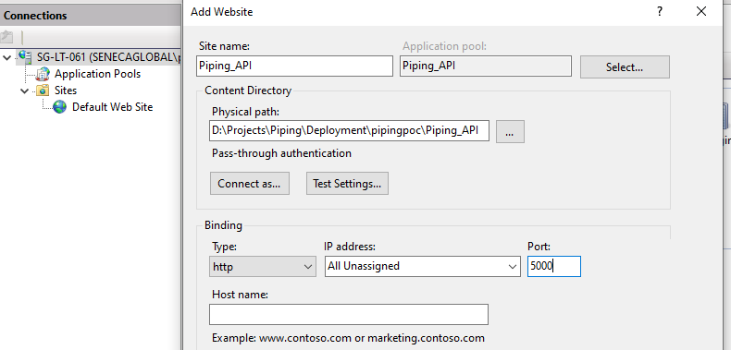

1. In Application pools, select Piping API. Select Basic Properties and set **.Net CLR version** to **No Managed Code**

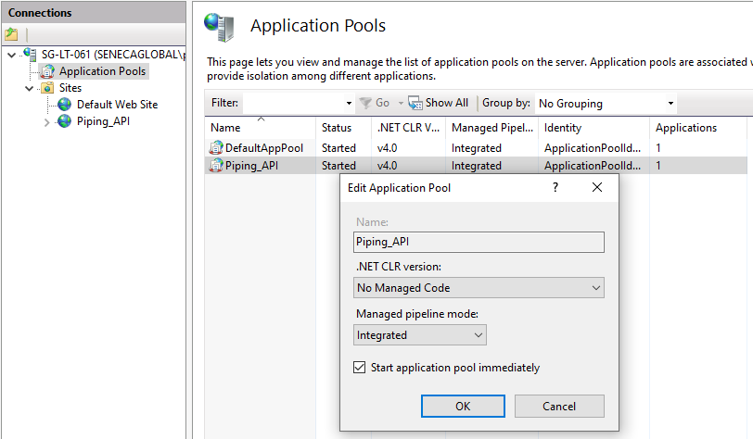

**PIPING UI Deployment in IIS**

1. Deploy extracted Piping_UI folder in IIS. Add Website Piping_UI in IIS

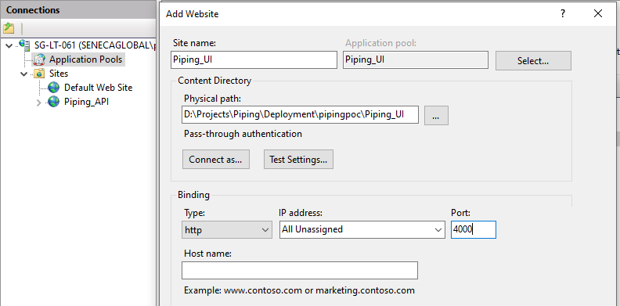

**PIPING DB scripts migration**

* Create database in Postgresql.
* Execute the scripts file Piping_DB/PipingDBScripts.sql

1. **Test**

Verify whether API, UI and DB are working

|  |  |  |
| --- | --- | --- |
| **#** | **Application** |  |
| 1 | API | <http://localhost:5000> |
| 2 | UI | <http://localhost:4000> |
| 3 | DB | Piping_Test |

**Piping API**

<http://localhost:5000>

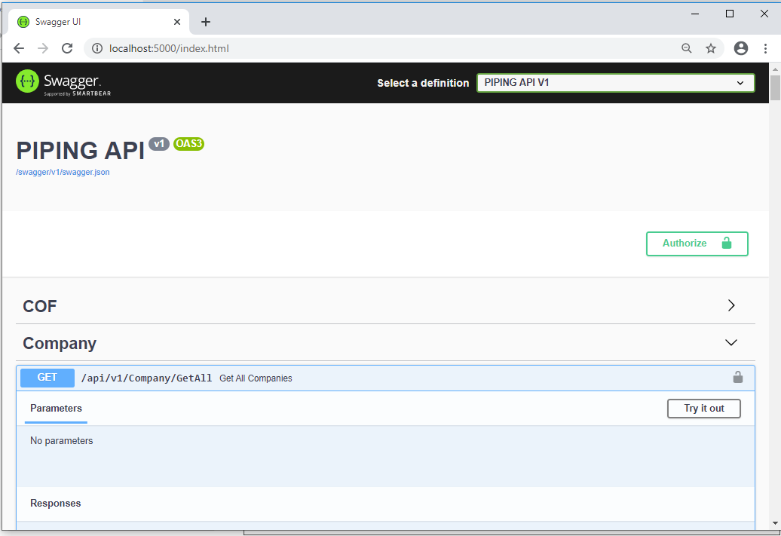

**Piping UI**

<http://localhost:4000>

|  |  |  |
| --- | --- | --- |
| **Login Credentials** | **Username** | **Password** |
|  | E0001 | password |

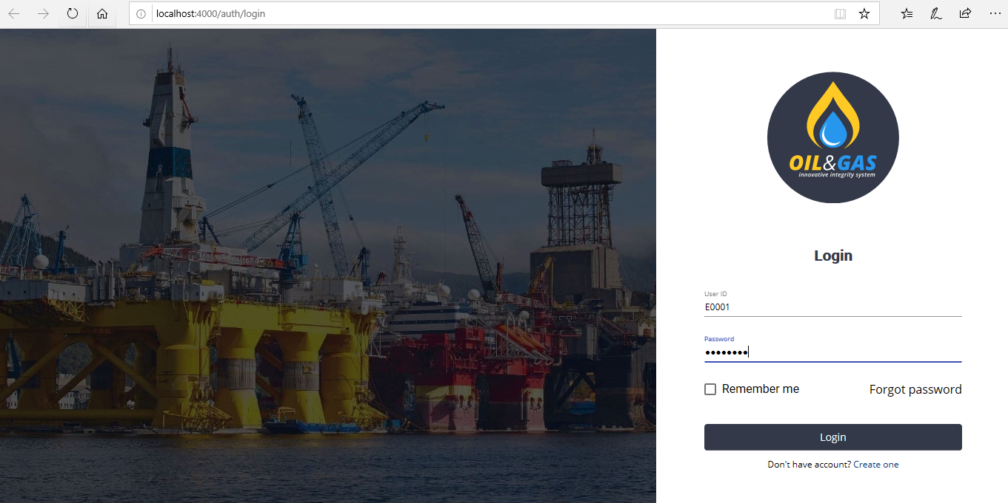

**Pipe Master Import**

Use thePiping_DB/PipeMasterData_BulkImport.xlsx file to import Pipe Master data.

